Vulkan t-shirt size {M,L,XL,XXL,Any}

CS 550

Final Project Report

Omkar Thakur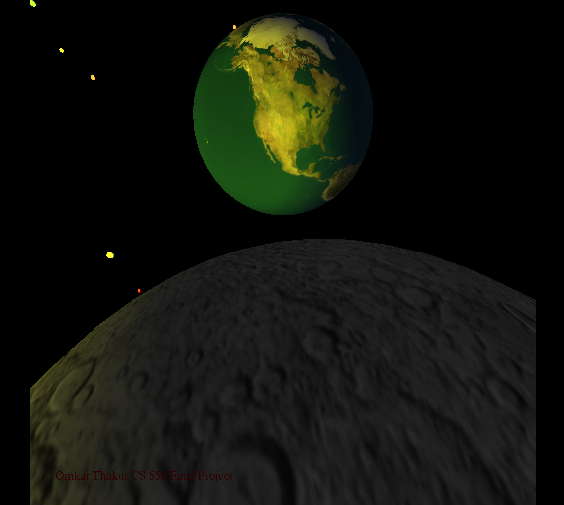

Vulkan t-shirt size {M,L,XL,XXL,Any}

**Final Report:**

In the following project, sun is the light source for all the celestial bodies including earth and moon. The rocket is seen going from near the earth. It has orange colored flame. The suns light is partially on the earth, moon and the rocket. The celestial bodies have their uniform velocity. The light of the sun is also reflected on the celestial bodies. Various views are presented in this project.

1. Seeing Oregon from the Moon
2. Seeing the world from Oregon.
3. Movie like automatic zoom in and zoom out view of the entire scene.
4. A mirror of the entire scene, where in the earth serves as a center. Due to which there will be two suns, two moons, 2 rockets and twice number of the celestial bodies.
5. A view from the sun seeing earth

I did not expect to create many of those effects with views. Different equations created different views such as the mirroring effect. While the flame for the rocket is made from rotating two cones, a shade of red is also used from below to give an orange and red effect of flames. The rocket body is made from cone. A different velocity has been used for each celestial body for its uniform motion. The time function with some modification is used to move the celestial bodies, rocket, its flame. I knew that it will work with the time function that was the reason for me proposing this type of project. The things I never expected to work are the zoom in and zoom out camera. It worked with the following equation in glulookat.

**gluLookAt(15., 4, 10 * sin(1 * M_PI*Time2 / 200) * 5, 0., 0., 0., 0., 1., 0.);**

I also modified the time function for this.

**Time2 = (float)ms / (float)MS_PER_CYCLE + Time2;**

Therefore, due to incrementing, I got a continuous movie like effect

Due to this I got a continuous effect of the Time function where it just doesn’t have two states of 0 and 1. I think the zoom in and zoom out effect in this project is my **best effect** in this.

Near view with automatic zoom in effect:

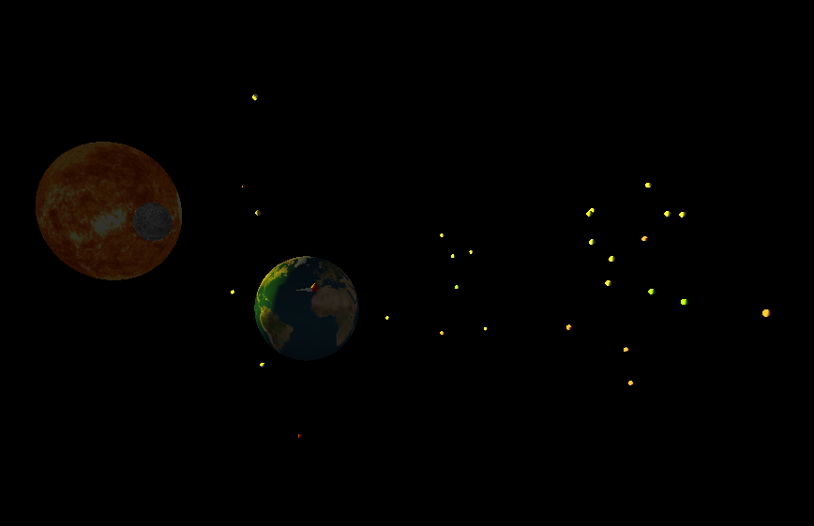

Farview with automatic zoom out effect: 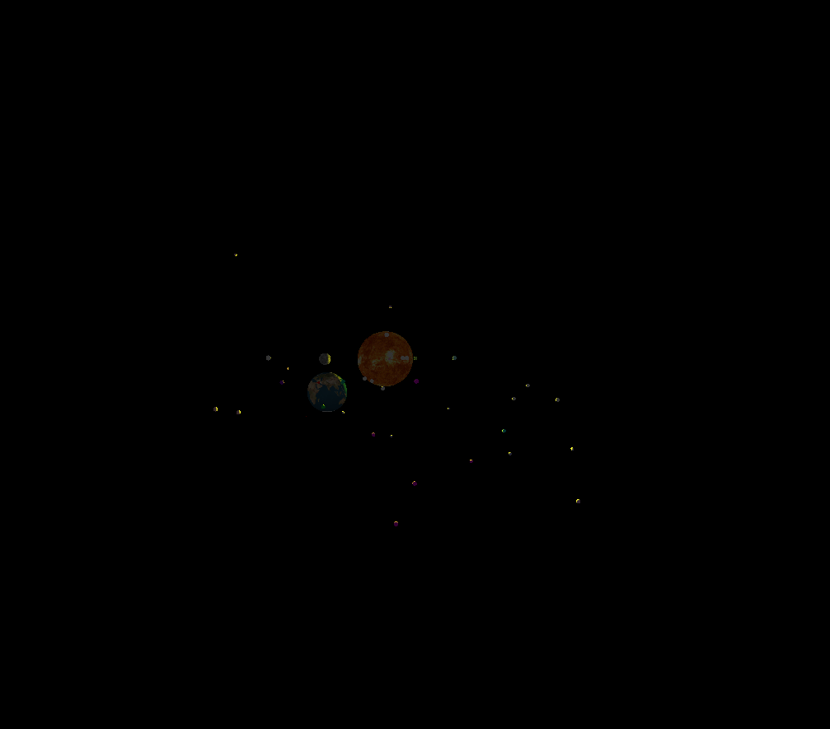

Inside out Oregon view:

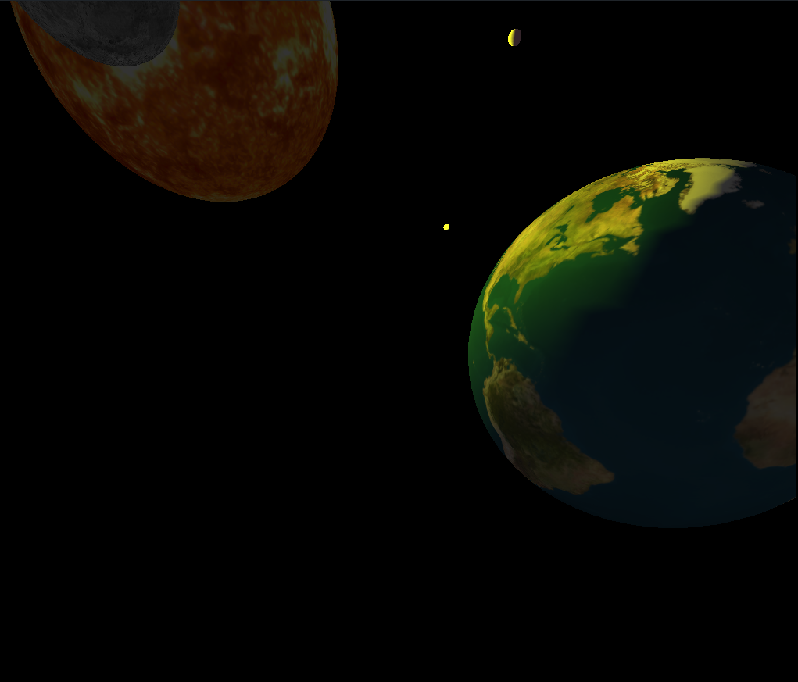

Sun view of the earth

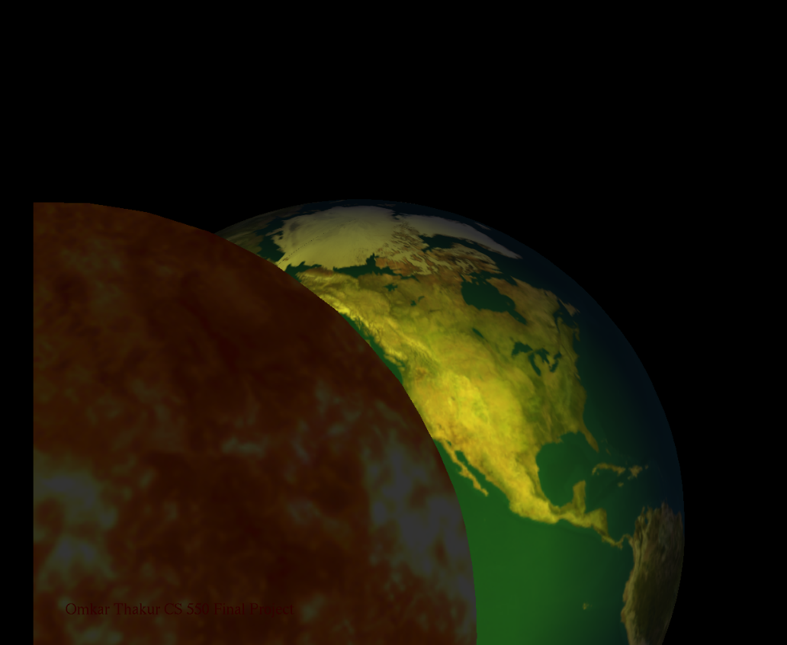

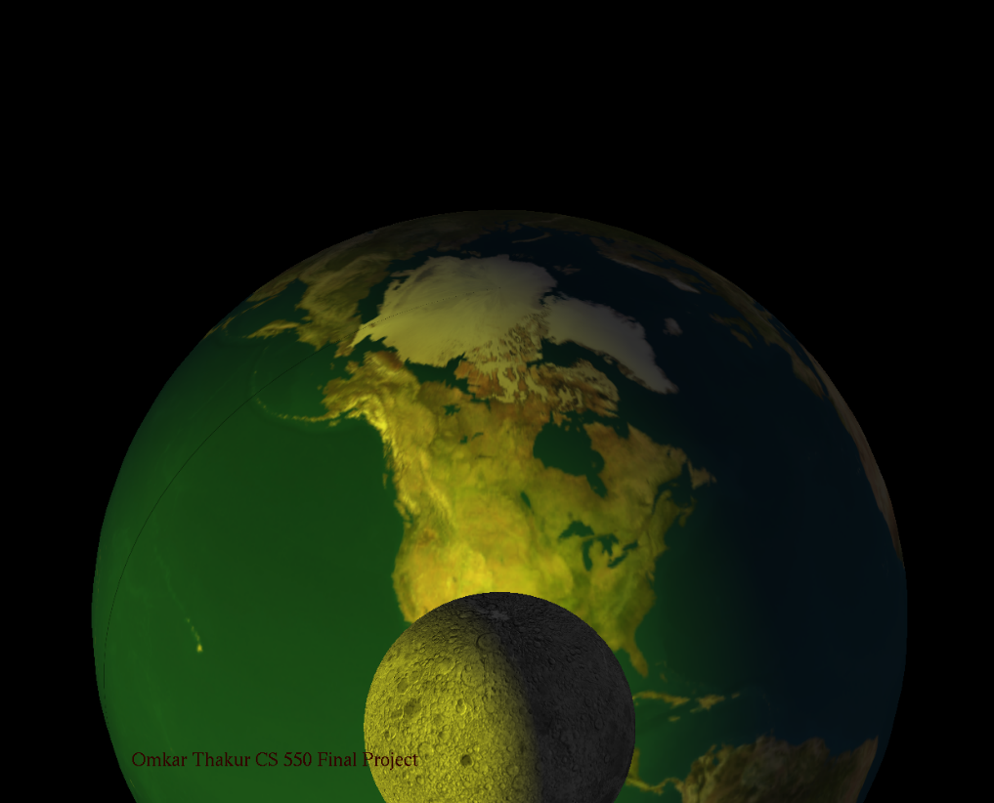Earth view from moon

Earth view as Prof Bailey suggested:



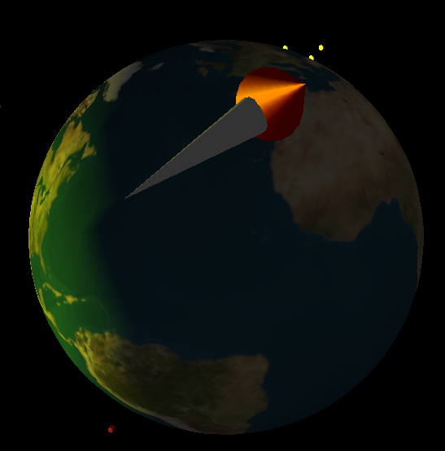

The above screenshot cannot show the rotation. Due to which the flame cannot be seen. You need to play the project to see the total effects.I just proposed whatever was doable for me within time limit. But while performing it I learned many new things with glulook out. My idea of creating a rocket with flame where flame is made by rotating two cones actually worked. I also gave it a good motion.. So rocket and flame moved together. The idea of celestial bodies with independent movement was time consuming though. I used sun as a light source and made sure that the obects are partially in light as I proposed. I have not given key binding for one of the moon view (labelled as perfect moon), because it was causing disruption in other views. I have also made two satellites which move around earth as I said in proposal. I think my project does not differ that much from proposal. **In fact, I have done extra things as follows:**

1. Automatic zoom in and zoom out effects
2. Mirror viewing angle, where earth serves as center.
3. Sun view.

**Things I missed:**

1. Fog around the celestial bodies.

**Time:**

Though I had hard time adjusting certain things in this project, it was fun. Approximate time put in this project is 30 hours.

**Text from proposal:**

Final Project Proposal

Earths view from the moon. The placement of the eye position will be on the moon and it can see earth partially. The earth’s sphere will be in partial light and partial darkness. A rocket will be also seen coming from the earth to moon. Maximum amount of celestial bodies with some planets will also be shown in

the project.

Appropriate lightning will also be applied on the celestial bodies as well as the moon and the earth. A rocket will also be shown travelling from earth to outer space. A slight flame may be seen on the rocket. The rocket will also transition from a surface having light to a dark surface. Some small satellites may be seen. This is because, this project is based more on creativity than reality. Therefore, the size of the rocket will be more than the relative size of the rocket. This is because it should be seen by eyes.

The planets and the celestial bodies may not move. But planet earth might show some movement. This is for the project to be more challenging. I also have an idea to show some amount of fog in project around planet earth. But this may or may not be fulfilled. Some of the stars will also be shown. Attenuation of light formed with many stars may or may not be seen. But I can give a try for that

**Instructions to run the project:**

Step 1:

Press keys 2 and 3 (lighting)

Step 2:

Press key 6 (automatic zoom in and zoom out). 6 again to exit the view

Step 3:

Press key 5 (moon view). Press 5 again to exit it

Step 6:

Press 4 to get inside out view. 4 again to exit it

Step 7:

Press 7 for mirroring effect. 7 again to exit it.